ECE 290

Project 2 Proposal

Group AL3 – 19

Nov.30, 2013

ECE 290 Project 2 Proposal of Group AL3 - 19

This time, our group decided to make several games by using the Arduino board. The input of the users will come from the keyboard. At the same time the output will show up on a LED display board. The Arduino will be used for the programmable micro-controller to easily toggle each LED fast enough.

**Part 1: Hardware**

*(1) The Arduino Boards*

We are using the Sparkfun ProtoSnap pro mini board this time.

The link of the information of this specific board is <https://www.sparkfun.com/tutorials/303>.

The link of functions of the pins of the Arduino board is <http://arduino.cc/en/Tutorial/DigitalPins>.

According to the schematic of the Arduino board:

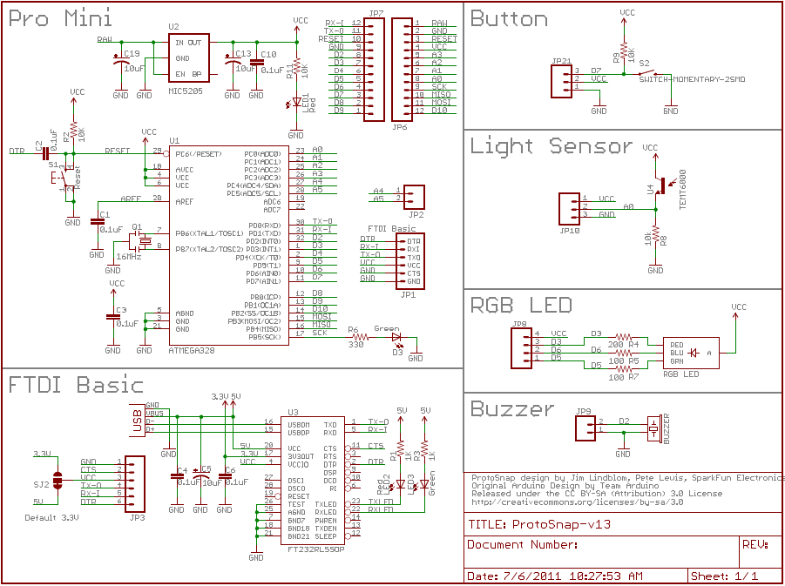

We only kept the Pro – Mini piece for the functions.

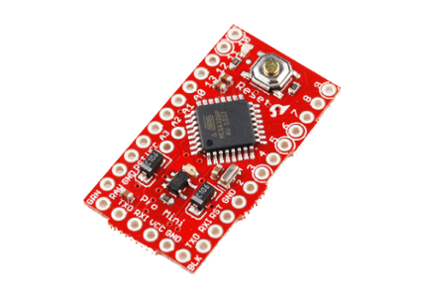.

*(2) The LED display board (8*8 matrix):*

i) The link of this LED display board is: <http://oomlout.com/8X8M/8X8M-Guide.pdf>.

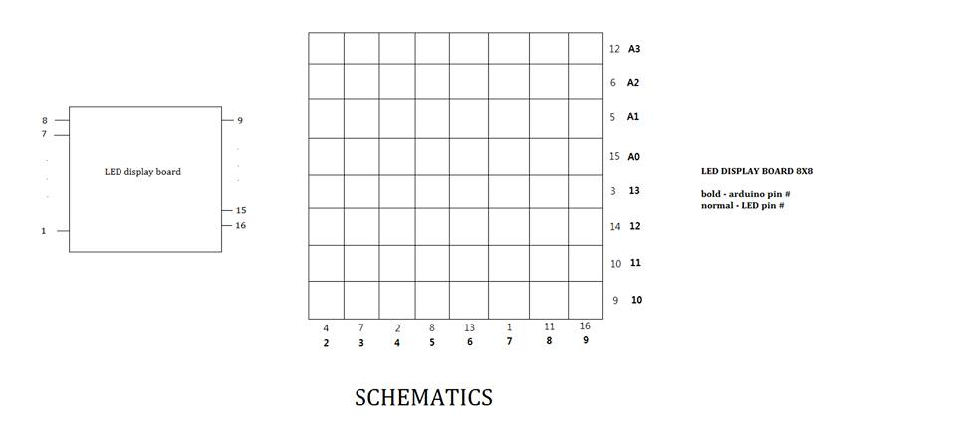

*ii) The principals of lighting the specific LEDs:*

Because LEDs are basically diodes. And every LED has two coordinates: one column number and one row number. So we first set the voltage of the column number low and the voltage of row number high as the initial state. Then, if we want to light up one particular LED, then we just need to flip the voltage of the columns to high voltage and the voltage of the row numbers to low. It’s kind of flipping the voltage. Plus, in the program, the rightmost A0 stands for pin 14, A1 stands for pin 15, A2 stands for pin 16, and A3 stands for pin 17. By the way, if we want to light up the diagonal LEDs to make it a diagonal shape, then we first light up the leftmost, then shut it off, light the next one. Because the lighting time is so short, human’s eyes cannot catch that. Same way applies to the lighting of LEDs line by line.

**Part 2: Software**

As stated previously, the software part is basically setting up the row number and column number’s voltages and the LED’s brightening time.

**Part 3: Combination**

The link of the combination part tutorial is: tinyurl.com/cmn5nh.

First we collected all the parts from the service shop, including the breadboard, wires, battery, buttons and the current limiting resistors. After carefully examining the Arduino board, we soldered all the pins on the Pro – mini piece. After putting Arduino board and LED display on the breadboard, we connect eight 220 ohms current limiting resistor to limit the current going through all the LEDs. Then we connected the power source 5V for the standard operation and connect the breadboard ground stripe to the Arduino grounds.

**Part 4: Test, Debug and Demo**

After plugging in the USB cable and uploading the program. We debugged a lot to let it finally work fine.  
Here is the demo video of our first game made by Paul, called stack.

Here is the link to the demo of this game:



And thank you!